**Task 1:** Develop a program that capture 10 Ethernet frames from the network and display the source and destination MAC addresses along with the data in each of the frames.

**Program:**

import socket, sys

from struct import *

#Convert a string of 6 characters of ethernet address into a dash separated hex string

def eth_addr (a) :

b = "%.2x:%.2x:%.2x:%.2x:%.2x:%.2x" % (ord(a[0]) , ord(a[1]) , ord(a[2]), ord(a[3]), ord(a[4]) , ord(a[5]))

return b

#create a AF_PACKET type raw socket (thats basically packet level)

#define ETH_P_ALL 0x0003 /* Every packet (be careful!!!) */

try:

s = socket.socket( socket.AF_PACKET , socket.SOCK_RAW , socket.ntohs(0x0003))

except socket.error , msg:

print 'Socket could not be created. Error Code : ' + str(msg[0]) + ' Message ' + msg[1]

sys.exit()

# receive a packet

for i in range(0, 10):

print

print '--PACKET '+str(i+1)+'--'

print

packet = s.recvfrom(65565)

#packet string from tuple

packet = packet[0]

#parse ethernet header

eth_length = 14

eth_header = packet[:eth_length]

eth = unpack('!6s6sH' , eth_header)

eth_protocol = socket.ntohs(eth[2])

print 'Destination MAC : ' + eth_addr(packet[0:6]) + ' Source MAC : ' + eth_addr(packet[6:12]) + ' Protocol : ' + str(eth_protocol)

print '--ETHERNET HEADER--'

#Parse IP header

#take first 20 characters for the ip header

ip_header = packet[eth_length:20+eth_length]

#now unpack them

iph = unpack('!BBHHHBBH4s4s' , ip_header)

version_ihl = iph[0]

version = version_ihl >> 4

ihl = version_ihl & 0xF

iph_length = ihl * 4

ttl = iph[5]

protocol = iph[6]

s_addr = socket.inet_ntoa(iph[8]);

d_addr = socket.inet_ntoa(iph[9]);

print 'Version : ' + str(version) + ' IP Header Length : ' + str(ihl) + ' TTL : ' + str(ttl) + ' Protocol : ' + str(protocol) + ' Source Address : ' + str(s_addr) + ' Destination Address : ' + str(d_addr)

#TCP protocol

if protocol == 6 :

print '--TCP--'

t = iph_length + eth_length

tcp_header = packet[t:t+20]

#now unpack them :)

tcph = unpack('!HHLLBBHHH' , tcp_header)

source_port = tcph[0]

dest_port = tcph[1]

sequence = tcph[2]

acknowledgement = tcph[3]

doff_reserved = tcph[4]

tcph_length = doff_reserved >> 4

print 'Source Port : ' + str(source_port) + ' Dest Port : ' + str(dest_port) + ' Sequence Number : ' + str(sequence) + ' Acknowledgement : ' + str(acknowledgement) + ' TCP header length : ' + str(tcph_length)

h_size = eth_length + iph_length + tcph_length * 4

data_size = len(packet) - h_size

#get data from the packet

data = packet[h_size:]

print 'Data : ' + data

#ICMP Packets

elif protocol == 1 :

print '--ICMP--'

u = iph_length + eth_length

icmph_length = 4

icmp_header = packet[u:u+4]

#now unpack them :)

icmph = unpack('!BBH' , icmp_header)

icmp_type = icmph[0]

code = icmph[1]

checksum = icmph[2]

print 'Type : ' + str(icmp_type) + ' Code : ' + str(code) + ' Checksum : ' + str(checksum)

h_size = eth_length + iph_length + icmph_length

data_size = len(packet) - h_size

#get data from the packet

data = packet[h_size:]

print 'Data : ' + data

#UDP packets

elif protocol == 17 :

print '--UDP--'

u = iph_length + eth_length

udph_length = 8

udp_header = packet[u:u+8]

#now unpack them :)

udph = unpack('!HHHH' , udp_header)

source_port = udph[0]

dest_port = udph[1]

length = udph[2]

checksum = udph[3]

print 'Source Port : ' + str(source_port) + ' Dest Port : ' + str(dest_port) + ' Length : ' + str(length) + ' Checksum : ' + str(checksum)

h_size = eth_length + iph_length + udph_length

data_size = len(packet) - h_size

#get data from the packet

data = packet[h_size:]

print 'Data : ' + data

#IGMP packets

elif protocol == 88 :

print '--IGMP--'

u = iph_length + eth_length

igmph_length = 8

igmp_header = packet[u:u+8]

#now unpack them :)

igmph = unpack('!HHHH' , igmp_header)

source_port = igmph[0]

dest_port = igmph[1]

length = igmph[2]

checksum = igmph[3]

print 'Source Port : ' + str(source_port) + ' Dest Port : ' + str(dest_port) + ' Length : ' + str(length) + ' Checksum : ' + str(checksum)

h_size = eth_length + iph_length + igmph_length

data_size = len(packet) - h_size

#get data from the packet

data = packet[h_size:]

print 'Data : ' + data

#some other IP packet

else :

print 'Protocol other than TCP/UDP/ICMP/IGMP'

print

**Output**

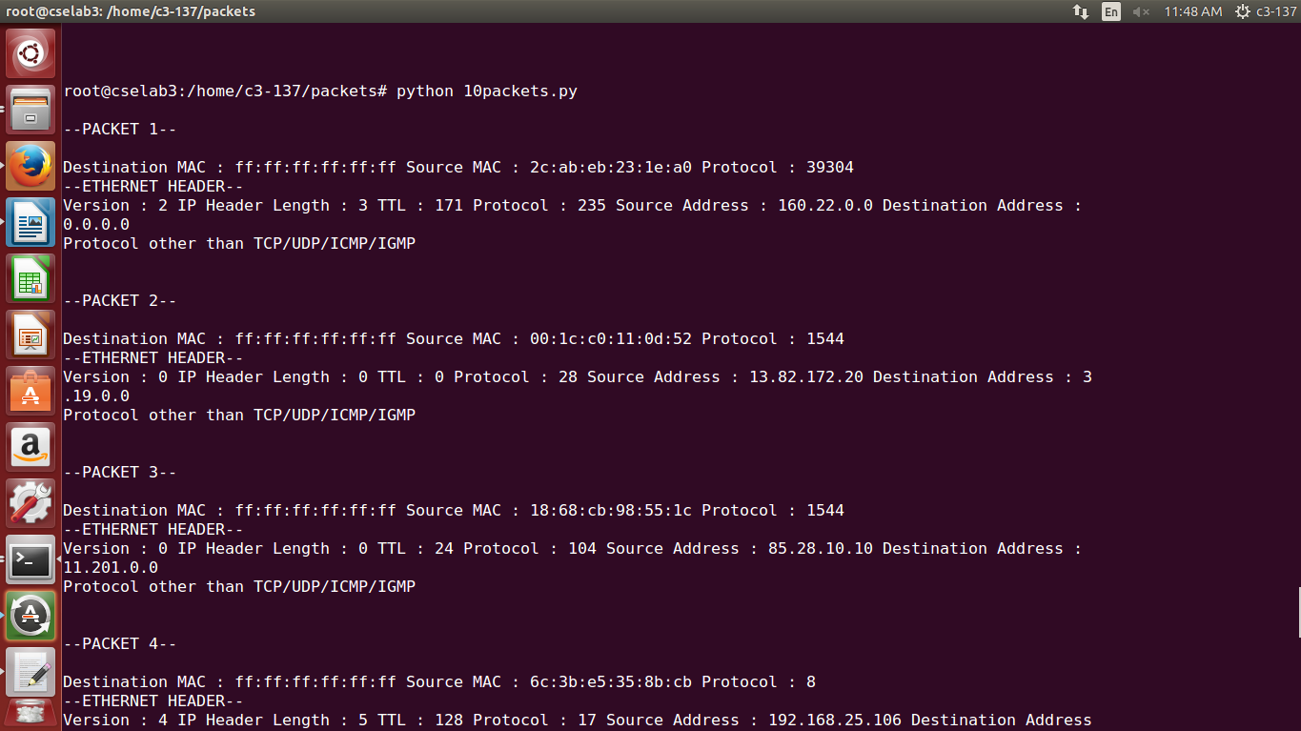

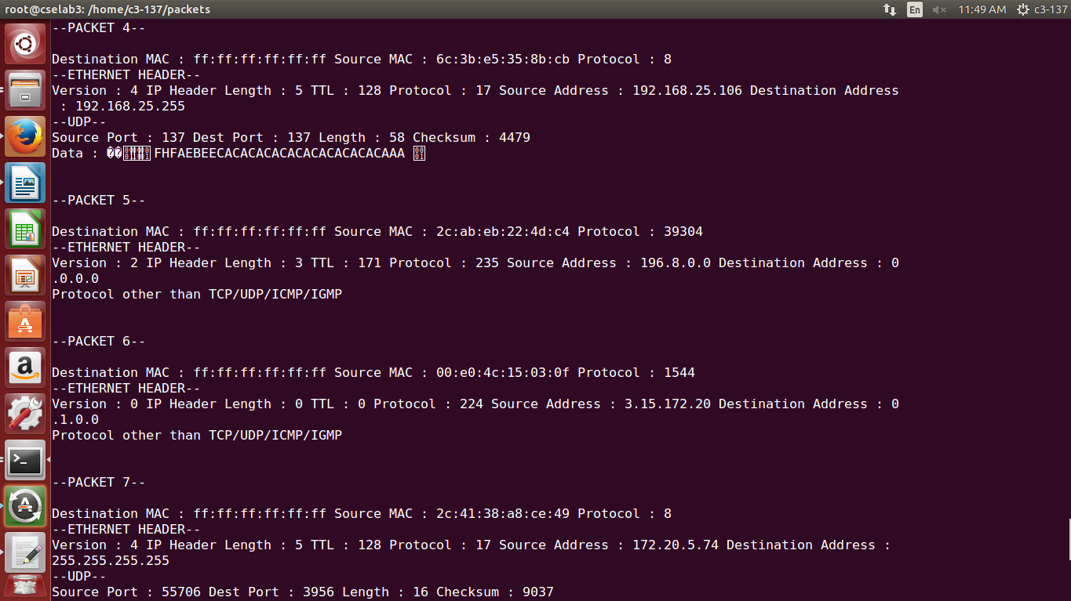

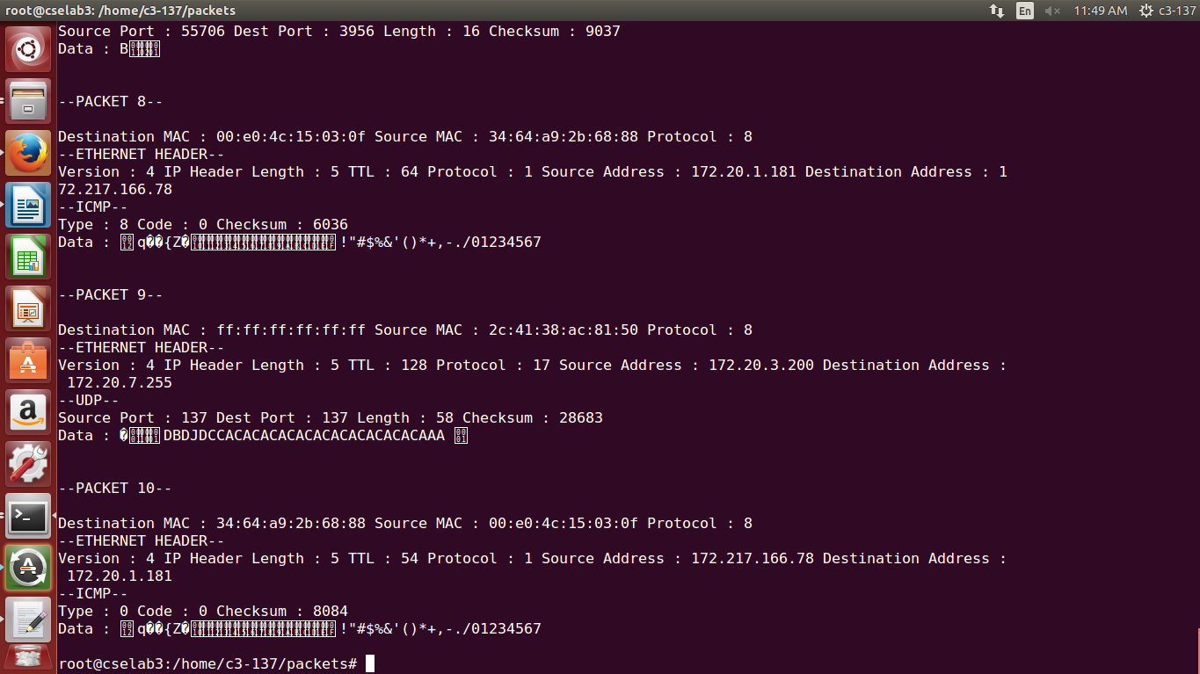

**Task 2:** Develop a program that capture n packets and displays the complete packet details including the headers.

**Program:**

import socket, sys

from struct import *

#Convert a string of 6 characters of ethernet address into a dash separated hex string

def eth_addr (a) :

b = "%.2x:%.2x:%.2x:%.2x:%.2x:%.2x" % (ord(a[0]) , ord(a[1]) , ord(a[2]), ord(a[3]), ord(a[4]) , ord(a[5]))

return b

#create a AF_PACKET type raw socket (thats basically packet level)

#define ETH_P_ALL 0x0003 /* Every packet (be careful!!!) */

try:

s = socket.socket( socket.AF_PACKET , socket.SOCK_RAW , socket.ntohs(0x0003))

except socket.error , msg:

print 'Socket could not be created. Error Code : ' + str(msg[0]) + ' Message ' + msg[1]

sys.exit()

n = input('Enter number of packets you want: ')

# receive a packet

for i in range(0, n):

print

print '--PACKET '+str(i+1)+'--'

print

packet = s.recvfrom(65565)

#packet string from tuple

packet = packet[0]

#parse ethernet header

eth_length = 14

eth_header = packet[:eth_length]

eth = unpack('!6s6sH' , eth_header)

eth_protocol = socket.ntohs(eth[2])

print 'Destination MAC : ' + eth_addr(packet[0:6]) + ' Source MAC : ' + eth_addr(packet[6:12]) + ' Protocol : ' + str(eth_protocol)

print '--ETHERNET HEADER--'

#Parse IP header

#take first 20 characters for the ip header

ip_header = packet[eth_length:20+eth_length]

#now unpack them

iph = unpack('!BBHHHBBH4s4s' , ip_header)

version_ihl = iph[0]

version = version_ihl >> 4

ihl = version_ihl & 0xF

iph_length = ihl * 4

ttl = iph[5]

protocol = iph[6]

s_addr = socket.inet_ntoa(iph[8]);

d_addr = socket.inet_ntoa(iph[9]);

print 'Version : ' + str(version) + ' IP Header Length : ' + str(ihl) + ' TTL : ' + str(ttl) + ' Protocol : ' + str(protocol) + ' Source Address : ' + str(s_addr) + ' Destination Address : ' + str(d_addr)

#TCP protocol

if protocol == 6 :

print '--TCP--'

t = iph_length + eth_length

tcp_header = packet[t:t+20]

#now unpack them :)

tcph = unpack('!HHLLBBHHH' , tcp_header)

source_port = tcph[0]

dest_port = tcph[1]

sequence = tcph[2]

acknowledgement = tcph[3]

doff_reserved = tcph[4]

tcph_length = doff_reserved >> 4

print 'Source Port : ' + str(source_port) + ' Dest Port : ' + str(dest_port) + ' Sequence Number : ' + str(sequence) + ' Acknowledgement : ' + str(acknowledgement) + ' TCP header length : ' + str(tcph_length)

h_size = eth_length + iph_length + tcph_length * 4

data_size = len(packet) - h_size

#get data from the packet

data = packet[h_size:]

print 'Data : ' + data

#ICMP Packets

elif protocol == 1 :

print '--ICMP--'

u = iph_length + eth_length

icmph_length = 4

icmp_header = packet[u:u+4]

#now unpack them :)

icmph = unpack('!BBH' , icmp_header)

icmp_type = icmph[0]

code = icmph[1]

checksum = icmph[2]

print 'Type : ' + str(icmp_type) + ' Code : ' + str(code) + ' Checksum : ' + str(checksum)

h_size = eth_length + iph_length + icmph_length

data_size = len(packet) - h_size

#get data from the packet

data = packet[h_size:]

print 'Data : ' + data

#UDP packets

elif protocol == 17 :

print '--UDP--'

u = iph_length + eth_length

udph_length = 8

udp_header = packet[u:u+8]

#now unpack them :)

udph = unpack('!HHHH' , udp_header)

source_port = udph[0]

dest_port = udph[1]

length = udph[2]

checksum = udph[3]

print 'Source Port : ' + str(source_port) + ' Dest Port : ' + str(dest_port) + ' Length : ' + str(length) + ' Checksum : ' + str(checksum)

h_size = eth_length + iph_length + udph_length

data_size = len(packet) - h_size

#get data from the packet

data = packet[h_size:]

print 'Data : ' + data

#IGMP packets

elif protocol == 88 :

print '--IGMP--'

u = iph_length + eth_length

igmph_length = 8

igmp_header = packet[u:u+8]

#now unpack them :)

igmph = unpack('!HHHH' , igmp_header)

source_port = igmph[0]

dest_port = igmph[1]

length = igmph[2]

checksum = igmph[3]

print 'Source Port : ' + str(source_port) + ' Dest Port : ' + str(dest_port) + ' Length : ' + str(length) + ' Checksum : ' + str(checksum)

h_size = eth_length + iph_length + igmph_length

data_size = len(packet) - h_size

#get data from the packet

data = packet[h_size:]

print 'Data : ' + data

#some other IP packet

else :

print 'Protocol other than TCP/UDP/ICMP/IGMP'

print

**Output:**

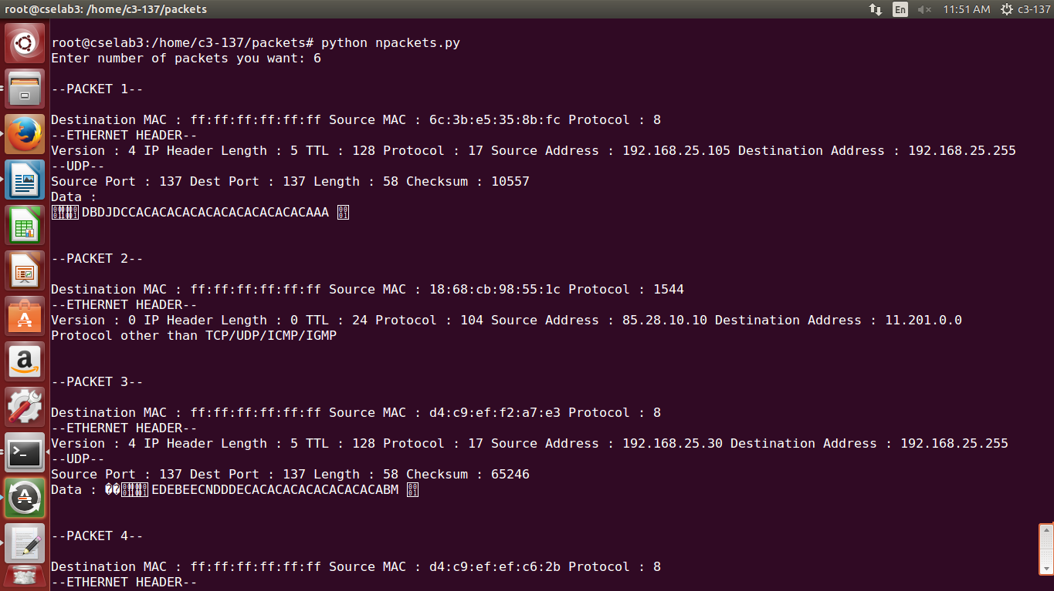

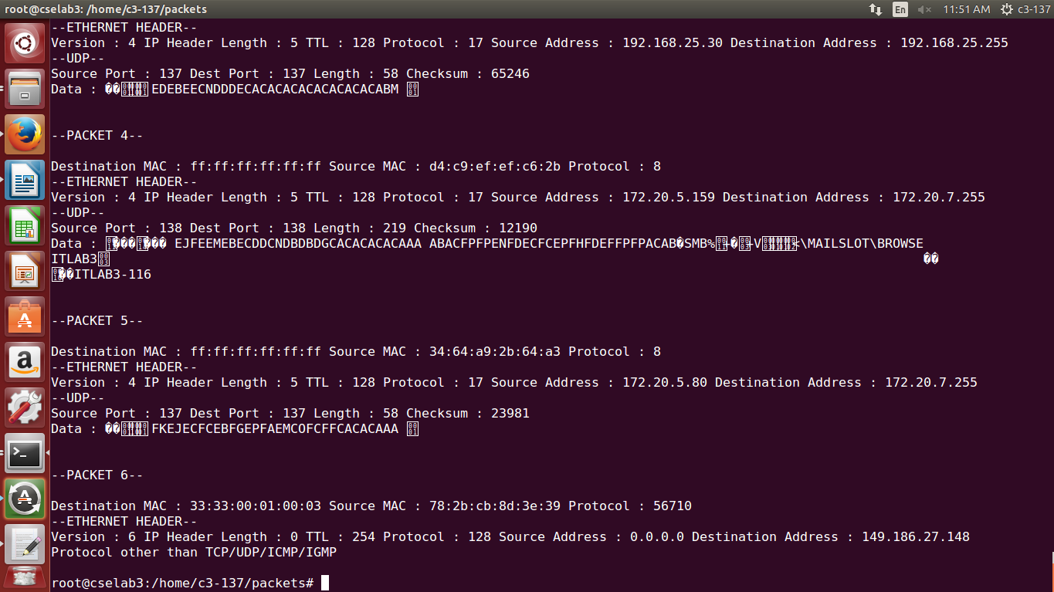

**Task 3:** Write a program to extract and print the TCP segment information including the header.

**Program:**

import socket, sys

from struct import *

#Convert a string of 6 characters of ethernet address into a dash separated hex string

def eth_addr (a) :

b = "%.2x:%.2x:%.2x:%.2x:%.2x:%.2x" % (ord(a[0]) , ord(a[1]) , ord(a[2]), ord(a[3]), ord(a[4]) , ord(a[5]))

return b

#create a AF_PACKET type raw socket (thats basically packet level)

#define ETH_P_ALL 0x0003 /* Every packet (be careful!!!) */

try:

s = socket.socket( socket.AF_PACKET , socket.SOCK_RAW , socket.ntohs(0x0003))

except socket.error , msg:

print 'Socket could not be created. Error Code : ' + str(msg[0]) + ' Message ' + msg[1]

sys.exit()

n = input('Enter number of packets you want: ')

i = 0

# receive a packet

while(i<n):

packet = s.recvfrom(65565)

#packet string from tuple

packet = packet[0]

#parse ethernet header

eth_length = 14

eth_header = packet[:eth_length]

eth = unpack('!6s6sH' , eth_header)

eth_protocol = socket.ntohs(eth[2])

#Parse IP header

#take first 20 characters for the ip header

ip_header = packet[eth_length:20+eth_length]

#now unpack them

iph = unpack('!BBHHHBBH4s4s' , ip_header)

version_ihl = iph[0]

version = version_ihl >> 4

ihl = version_ihl & 0xF

iph_length = ihl * 4

ttl = iph[5]

protocol = iph[6]

s_addr = socket.inet_ntoa(iph[8]);

d_addr = socket.inet_ntoa(iph[9]);

#TCP protocol

if protocol == 6 :

i+=1

print

print

print '--PACKET '+str(i)+'--'

print 'Destination MAC : ' + eth_addr(packet[0:6]) + ' Source MAC : ' + eth_addr(packet[6:12]) + ' Protocol : ' + str(eth_protocol)

print '--ETHERNET HEADER--'

print 'Version : ' + str(version) + ' IP Header Length : ' + str(ihl) + ' TTL : ' + str(ttl) + ' Protocol : ' + str(protocol) + ' Source Address : ' + str(s_addr) + ' Destination Address : ' + str(d_addr)

t = iph_length + eth_length

tcp_header = packet[t:t+20]

#now unpack them :)

tcph = unpack('!HHLLBBHHH' , tcp_header)

source_port = tcph[0]

dest_port = tcph[1]

sequence = tcph[2]

acknowledgement = tcph[3]

doff_reserved = tcph[4]

tcph_length = doff_reserved >> 4

print '--TCP--'

print 'Source Port : ' + str(source_port) + ' Dest Port : ' + str(dest_port) + ' Sequence Number : ' + str(sequence) + ' Acknowledgement : ' + str(acknowledgement) + ' TCP header length : ' + str(tcph_length)

h_size = eth_length + iph_length + tcph_length * 4

data_size = len(packet) - h_size

#get data from the packet

data = packet[h_size:]

print 'Data : ' + data

**Output:**

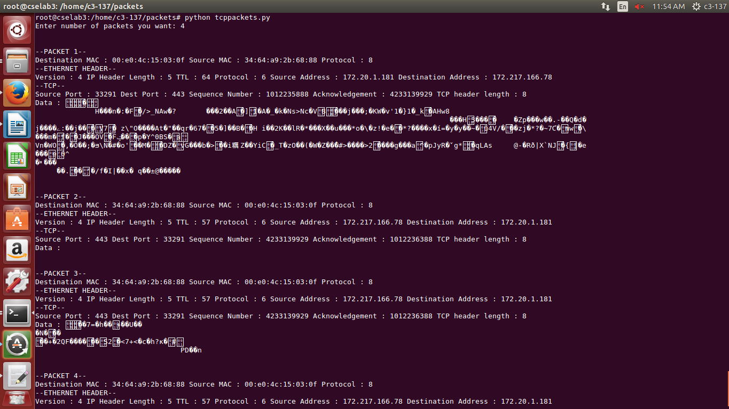

**Task 4:** Write a program to extract and print the UDP segment information.

**Program:**

import socket, sys

from struct import *

#Convert a string of 6 characters of ethernet address into a dash separated hex string

def eth_addr (a) :

b = "%.2x:%.2x:%.2x:%.2x:%.2x:%.2x" % (ord(a[0]) , ord(a[1]) , ord(a[2]), ord(a[3]), ord(a[4]) , ord(a[5]))

return b

#create a AF_PACKET type raw socket

try:

s = socket.socket( socket.AF_PACKET , socket.SOCK_RAW , socket.ntohs(0x0003))

except socket.error , msg:

print 'Socket could not be created. Error Code : ' + str(msg[0]) + ' Message ' + msg[1]

sys.exit()

n = input('Enter number of packets you want: ')

i = 0

# receive a packet

while(i<n):

packet = s.recvfrom(65565)

#packet string from tuple

packet = packet[0]

#parse ethernet header

eth_length = 14

eth_header = packet[:eth_length]

eth = unpack('!6s6sH' , eth_header)

eth_protocol = socket.ntohs(eth[2])

#Parse IP header

#take first 20 characters for the ip header

ip_header = packet[eth_length:20+eth_length]

#now unpack them

iph = unpack('!BBHHHBBH4s4s' , ip_header)

version_ihl = iph[0]

version = version_ihl >> 4

ihl = version_ihl & 0xF

iph_length = ihl * 4

ttl = iph[5]

protocol = iph[6]

s_addr = socket.inet_ntoa(iph[8]);

d_addr = socket.inet_ntoa(iph[9]);

if protocol == 17 :

i+=1

print

print

print '--PACKET '+str(i)+'--'

print 'Destination MAC : ' + eth_addr(packet[0:6]) + ' Source MAC : ' + eth_addr(packet[6:12]) + ' Protocol : ' + str(eth_protocol)

print '--UDP--'

u = iph_length + eth_length

udph_length = 8

udp_header = packet[u:u+8]

#now unpack them :)

udph = unpack('!HHHH' , udp_header)

source_port = udph[0]

dest_port = udph[1]

length = udph[2]

checksum = udph[3]

print 'Source Port : ' + str(source_port) + ' Dest Port : ' + str(dest_port) + ' Length : ' + str(length) + ' Checksum : ' + str(checksum)

h_size = eth_length + iph_length + udph_length

data_size = len(packet) - h_size

#get data from the packet

data = packet[h_size:]

print 'Data : ' + data

**Output:**

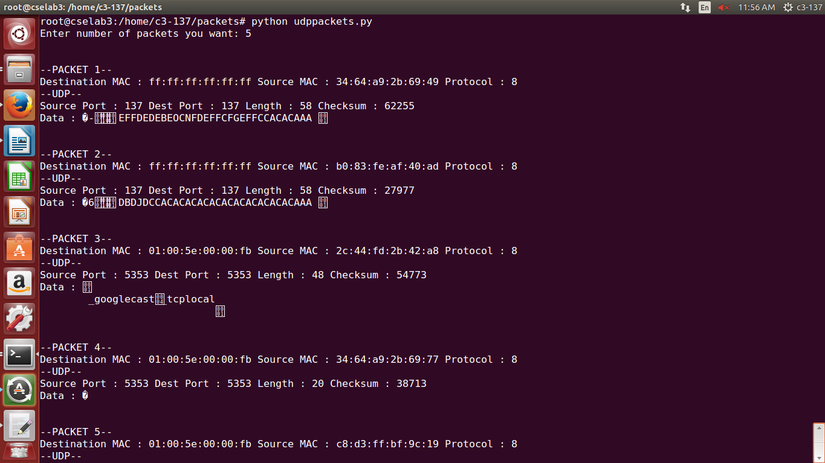

**Task 5:** Write a program that captures 100 packets and display the count of ICMP, IGMP, TCP, UDP, and IP packets.

**Program:**

import socket, sys

from struct import *

#Convert a string of 6 characters of ethernet address into a dash separated hex string

def eth_addr (a) :

b = "%.2x:%.2x:%.2x:%.2x:%.2x:%.2x" % (ord(a[0]) , ord(a[1]) , ord(a[2]), ord(a[3]), ord(a[4]) , ord(a[5]))

return b

#create a AF_PACKET type raw socket

try:

s = socket.socket( socket.AF_PACKET , socket.SOCK_RAW , socket.ntohs(0x0003))

except socket.error , msg:

print 'Socket could not be created. Error Code : ' + str(msg[0]) + ' Message ' + msg[1]

sys.exit()

# receive a packet

icmp = 0

tcp = 0

udp = 0

igmp = 0

for i in range(0, 1000):

packet = s.recvfrom(65565)

#packet string from tuple

packet = packet[0]

eth_length = 14

#Parse IP header

#take first 20 characters for the ip header

ip_header = packet[eth_length:20+eth_length]

#now unpack them

iph = unpack('!BBHHHBBH4s4s' , ip_header)

ttl = iph[5]

protocol = iph[6]

#TCP protocol

if protocol == 6 :

tcp+=1

#ICMP Packets

elif protocol == 1 :

icmp+=1

#UDP packets

elif protocol == 17 :

udp+=1

#IGMP Packets

elif protocol == 88 :

igmp+=1

sys.stdout.write("\rTCP: %d UDP: %d ICMP: %d IGMP: %d Total: %d" %(tcp, udp, icmp, igmp, i+1))

sys.stdout.flush()

print

**Output:**

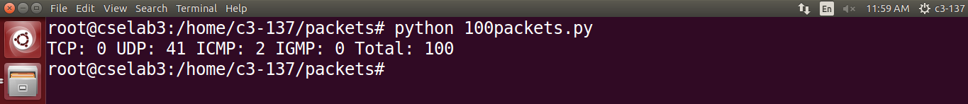

For 1000 packets,

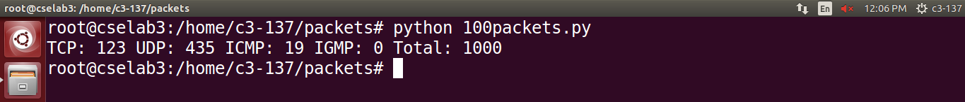

For 10,000 packets,

